

|  |  |  |
| --- | --- | --- |
| Mathematics Department | |  |
| Course: A2MAA | |
| Topic Title: Test 1 | |
| Student Name:_____________________________________ | Date: ____________ | | |
| Special Instructions: Formula Sheet and calculators Allowed | Time Allowed: 60 minutes | | |
|  | Marks: / 50 | | |

**Question 1.**

A vending machine dispenses five different types of soft drinks. Explain why the sales of each type of soft drink is an example of:

1. Categorical data. [1 mark]
2. Numerical data. [1 mark]

**Question 2.**

The table below shows the sales of mens shoes at a local market:

|  |  |  |  |  |  |  |
| --- | --- | --- | --- | --- | --- | --- |
| **Shoe size** | 8 | 9 | 10 | 11 | 12 | 13 |
| **Frequency** | 3 | 5 | 7 | 1 | 2 | 2 |

1. Calculate the mean shoe size. [2 marks]
2. Calculate the median shoe size. [2 marks]
3. Calculate the modal shoe size. [1 mark]
4. Which measure is of most use to the owner of the shoe store? [1 mark]

**Question 3.**

Five people have a mean weight of 67Kg. If a child weighing 43Kg was added to the group, what would the mean weight be? [3 marks]

**Question 4.**

Consider the frequency table shown below:

|  |  |
| --- | --- |
| **Score** | **Frequency** |
| 16 | 2 |
| 17 | 4 |
| 18 | 3 |
| 19 | 1 |
| 22 | 2 |
| 23 | 3 |
| 49 | 1 |

1. Calculate the mean and standard deviation of the above scores. [4 marks]
2. The score of 49 has been identified as an outlier. Remove the outlier and recalculate the mean and standard deviation. [4 marks]
3. What effect did this have on the mean and standard deviation and why? [2 marks]

**Question 5.**

Consider the data shown below:

32,51,63,17,44,65,69,68,73,8,74,72,35,63,52,26,56,72

1. Use the data to construct a stem and leaf plot. [3 marks]
2. Construct a box and whisker plot from the given data. [3 marks]
3. If an outlier is defined as any score more than 1.5 interquartile ranges above or below the upper and lower quartiles, identify all outliers. [2 marks]
4. What effect will the removal of the outliers have on the shape of the box and whisker plot?

[2 marks]

**Question 6.**

A student from a large school is investigating the weights of boys in his year group.

(a) Circle the best **two** of the four methods outlined below to pick a fair and unbiased sample of boys to weigh from his year group. [2 marks]

* 1. Choose the first five of his friends he talks to.
  2. Randomly pick the names of 20 students from a list of all students in his year group.
  3. During a year assembly, ask for 20 students to volunteer.
  4. Stand at the main school entrance before school starts and write down the name of every third boy from his year group who arrives.

The student weighed 24 students and their weights, in kg to one decimal place, are listed below.

65.2, 60.0, 62.8, 63.8, 58.9, 65.9, 69.0, 65.5, 67.9, 62.7, 58.4, 69.4

73.2, 66.3, 65.5, 64.4, 56.5, 63.4, 60.1, 56.3, 59.9, 64.7, 61.9, 63.6

(b) For these 24 weights, determine the range. [2 marks]

(c) Group this data, using the class intervals in the table below. [3 marks]

|  |  |
| --- | --- |
| Weight of boy (kg) | Frequency |
|  |  |
|  |  |
|  |  |
|  |  |
|  |  |
|  |  |
|  |  |
|  |  |

(d) Which is the modal class for the data in the frequency table? [1 mark]

(e) Use the grouped data from (c) to construct a frequency histogram on the axes below.

[3 marks]

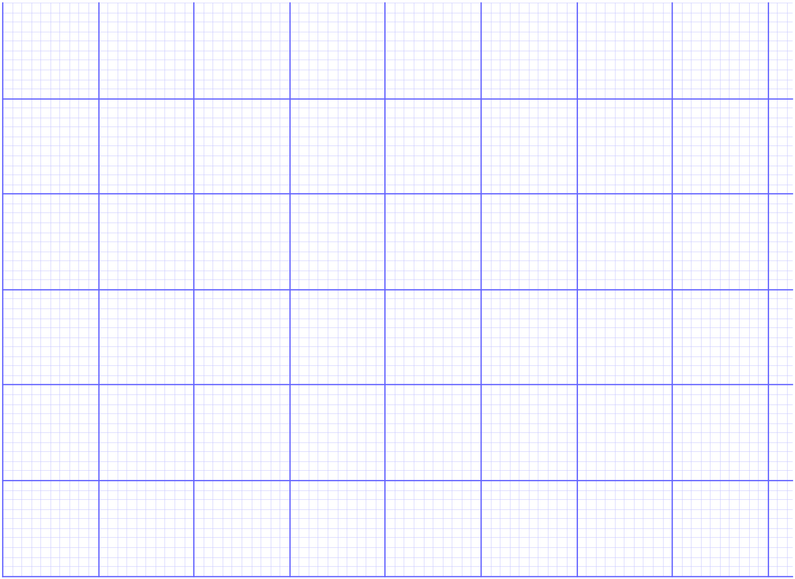

(f) Describe two features of the spread of weights shown in the histogram. [2 marks]

**Question 8.**

Consider the frequency histogram below. It shows the tooth length (to the nearest mm) in a particular species of fish.

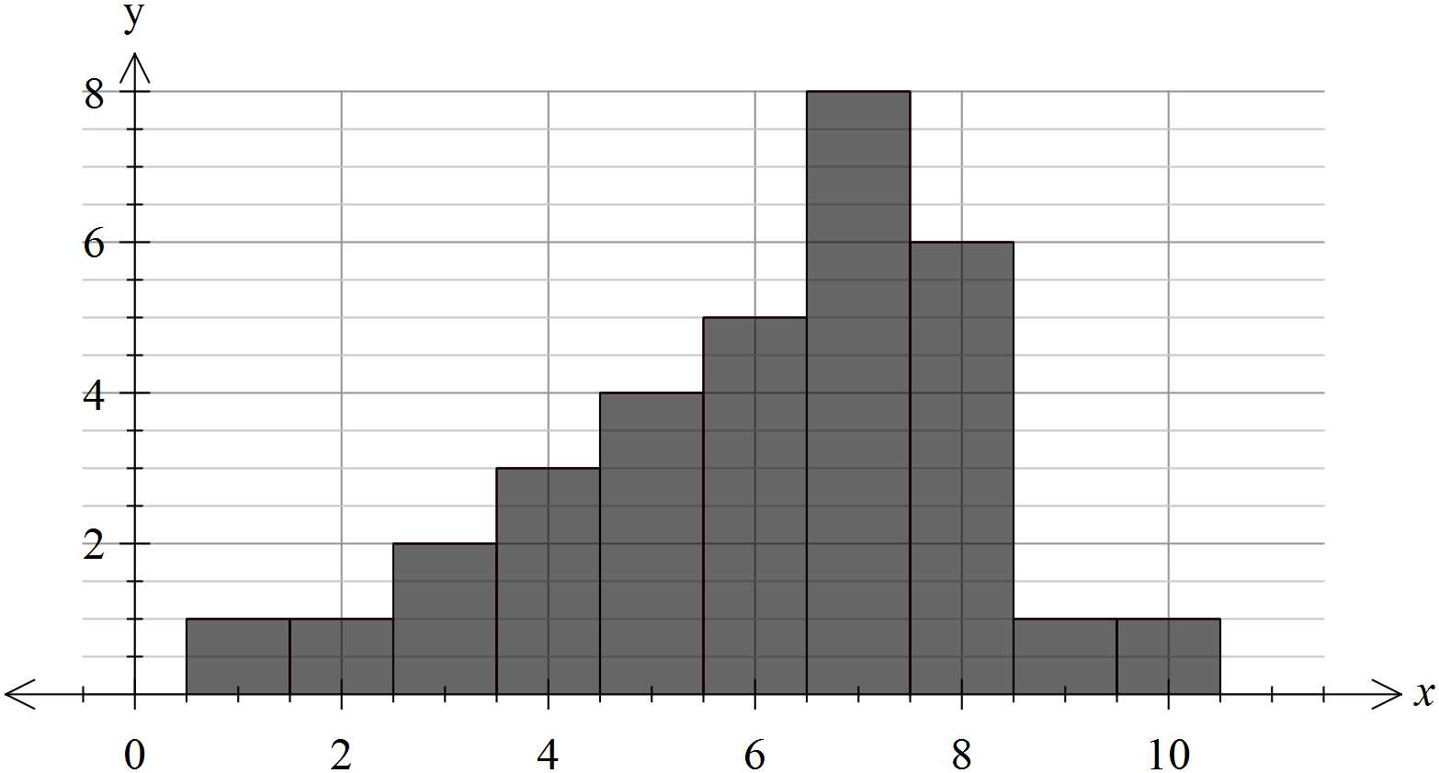

a) Calculate the mean for the data shown above. [2 marks]

b) Explain why your answer to a) is only an estimate of the mean. [1 mark]

c) Describe the distribution (location, spread, shape etc…) of the data provided. [3 marks]